**Highlights**

* + *Buttons* Page 2
    - Color classes
  + *Forms*
  + *Tables* Page 4
  + *Panels*
  + *Wells*
  + *Images* Page 5
  + *Media*
  + *Responsive Embed*
  + *Alerting Users Page 6* 
    - * *Labels*
      * *Badges*
      * *Alerts*
      * *Progress Bars*

**Bootstrap Buttons**

Colors in Bootstrap

* Default colors (name of bootstrap class):
  + Primary: Dark blue (–primary)
  + Success: green (–success)
  + Info: light blue (–info)
  + Warning: Yellowish orange (*–warning)
  + Danger: red (*–danger)
    - * – asterisk could be anything text, btn, alert, bg, etc.
* Bootstrap Button Classes
  + 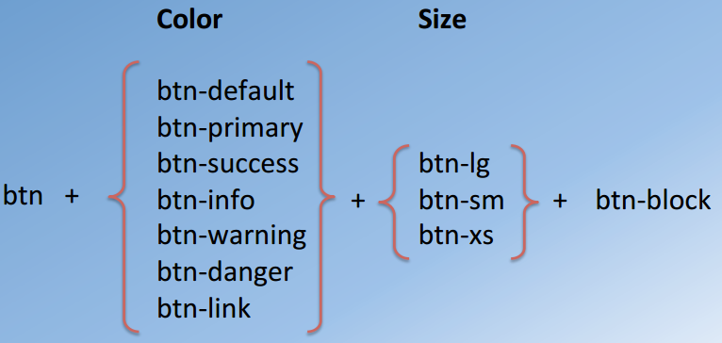
  + btn–block – it occupies the whole block for the button. If not specified, default will be used.
  + btn–group–*
    - * can be:
      * sm – small size
      * lg – large size
      * vertical – Vertical orientation

**Bootstrap Forms**

Basic Horizontal form

* class “form-horizontal”
  + With this labels will be shown on the left of input field
  + Create a div with “form-group” to enclose each input field. This class work as row class
* Class “form-inline”
  + When create a single line form
  + Labels tag are created with ***“sr-only”*** class.
    - Which means this label is visible only for screen reader not the available in the UI. Use placeholder instead to show to user
  + Example:
    - 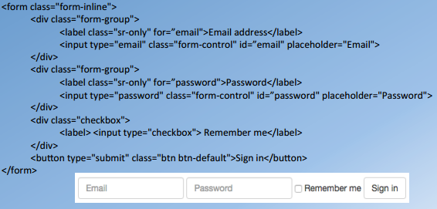
* class “input-group”
  + Allows to group together a set of elements
  + Use “input-group-addon” to add an element to left and right of the element

***Week 2***

**Tables –** it was originally used to display tabular data, but it is also being used to design and position web content

**Bootstrap Tables**

* **Important classes:**
  + table
  + table-striped
    - zebra striped rows
  + table-bordered
    - to border table cells
  + table-hover
    - to highlight rows when it is hovered
  + table-condensed
    - cutting the cell padding in half
  + table-responsive
    - making the table responsive. Turn table to horizontally scrolled tabled if it’s larger than what can fit in screen
  + Can also use color classes, such as: active, success, info, warning, and danger

**Panels and Wells –** thiscan be used tohighlight some content on the website.

* *Panel*
  + Allows to display a content in a bounded box.
  + Can have a heading for panel (bounded) box
  + 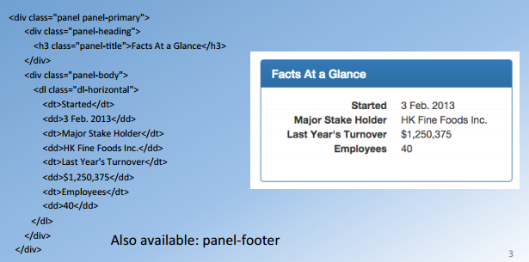
    - <dl> - tag for description list
      * dl-horizontal class so the term (<dt></dt>) and description (<dd></dd>) is displayed in the same line.
* *Well*
  + It shows a bounded box with a light grey background.
  + To use it apply ***well*** class to any div
  + 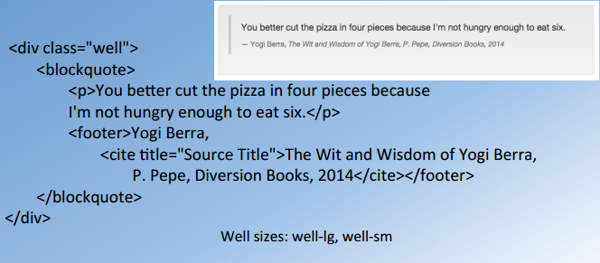
    - <blockquote>
      * It shows the text with vertical line displayed on the left side
      * We can apply footers for source of the quote n such

**Images and Media –** For Images use HTML <img src=“”> tag

* “thumbnail” class on div can be used to create gallery of image images that includes image and content (name and info about the person)
* Bootstrap Image Classes
  + img-responsive
    - scales with parent element
  + For shape of imge
    - ***img-rounded***: rounded corners
    - ***img-circle***: circular image
    - ***img-thumbnail***: thumbnail image
* Media Object
  + ***Media classes:***
    - *media:* applied to the parent div
    - *media-object*: to the child of media element
    - *media-body:* to the child of media-object element
    - *media-heading*: to the child of media-body element. It applied to heading in the media
  + ***Media positioning:***
    - media-left and media-right
      * if media-right is used it should always be child of media-body element.
    - media-top, media-middle, media-bottom
  + ***Media list:***
    - media-list is applied to list <ul> and media classes to <li>
  + ***Example:*** “media” class is applied to parent div
    - Then in child elements you have 2 classes
      * “media-left media-middle”
      * “media-body”
    - Result will show as:



**Responsive Embed –** For embedding some content on your application

* We can use <video>, <iframe>, or <embed> HTML tags to include media content (e.g. video) in the website
* Responsive Embed classes
  + embed-responsive
  + embed-responsive-*
    - * can be: ***16by9*** or ***4by3***
  + embed-responsive-item
    - this is applied to the actual tag that is used to embed the content. Listed above

**Alerting Users:**

* ***Simple Updates (Labels and Badges)***
  + For simple update to users. Ex: unread email or new items
  + ***Labels***
    - class=“label label-<color>”
      * color: default, primary, etc.
  + ***Badge***
    - Badge is self-collapsed when empty
  + ***Example:***
    - 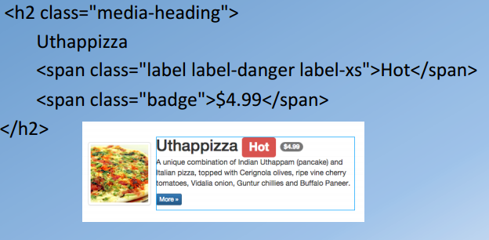
* ***Alert/Error/Warning messages***
  + Alert is another way to delivering message to the user.
  + Alert is surrounded by the bounding box with specified background color.
  + Using alert class
    - alert alert-<color> alert-dismissible
      * <color> can be warning, danger, etc.
      * Dismissible: that alert message can be dismissed
      * Also need to include a close button with data-dismiss=“alert” as shown in example
        + For ***alert-dismissible*** to work we need to bootstrap JavaScript plug-in installed
  + Example:
    - 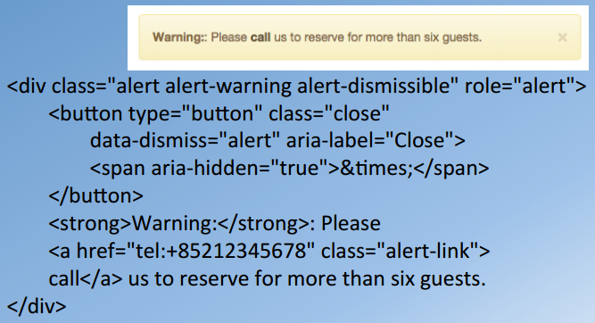
* ***Progress Bars***
  + Indicating any activity that is going on the website. Ex: downloading or uploading something
  + Using bootstrap progress bar
    - Parent div should have class “progress”
    - Child div should have:
      * progress-bar progress-bar-<color> progress-bar-striped
        + <color> can be warning, danger, info, etc. if this class not applied then default color will be used
        + If progress-bar-striped not applied then it will be solid bar. Also can use ***active*** class for animation
      * Style with with that indicated what percentage of progress bar is completed as shown in example below
  + Example:
    - 